Logbook Entry Window

Geoff Anderson G3NPA, Jim Hargrave W5IFP and Aki Yoshida JA1NLX

1.0 BASIC SETUP

As the name implies, this is the window through which the main entries are made to the logbook. It is quite complex and highly configurable so you are well advised to take time to study this section to fully understand what facilities are available from here. The picture shown below is the most basic Logbook Entry Window.

The top line shows the Frequency, Mode and Band that will be logged. The Frequency will be derived from your radio if you have CAT control and it is set up and activated. If you do not have computer control, then the frequency can be set manually. The Mode and Band will be derived from your Bandplan or, if desired, they also can be set manually. Below the top line are edit boxes for Callsign, RST Sent, RST Received, Name and QTH. You MUST enter a callsign at the very least before you can transfer anything to the log.

To change between edit boxes use the <TAB> key on the keyboard. Conversely the <Up Arrow> key will act as a Back-Tab <Shift+TAB> key combination. To transfer the QSO information to the logbook, use the key combination <Ctrl+L>_or the <Enter> key. If you wish to clear the whole entry window for any reason, use the <F11> key (if the focus is in the Logbook Entry window see help section explaining F11), the key combinations <Ctr-C>_or <Alt+W> or a left-click on the left side of the Logbook Entry window about 1/4 inch to the left of the entry fields. As a rule of thumb - click over Call, Sent, Rcvd, Name, Cmnt/QTH/Addr or bottom left user field caption.

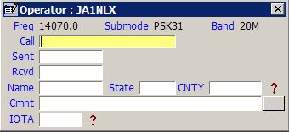

LBEW_1

Hew
Please put the link on “see help section explaining F11” which point “The F11 key explained” section.

